Python and GUI Implementation for Internal Optimization and Increased Usability of *in vivo* Glucose Sensing System

Kathryn DiPippo1,2, Alex Werth1, Michelle Zhang1,3, Phillip Heucke1,4, Jessica Doyle1,5, and Claire Gmachl1

1 Princeton University Department of Electrical Engineering, Princeton, NJ, 08540, USA

2 Permanent Address: Smith College, Northampton, MA, 01063, USA

3 Permanent Address: Rensselaer Polytechnic Institute, Troy, NY, 12180, USA

4 Permanent Address: Bucknell University, Lewisberg, PA, 17837, USA

5 Permanent Address: Hunterdon Central Regional High School, Flemington, NJ, 08822, USA email: dipippo@princeton.edu / dipipk@rpi.edu

Diabetes afflicts nearly 9.3% of the entire United States population and “remains the 7th leading cause of death in the United States”, according to 2014 statistics [1]. Diabetics must monitor their blood glucose levels to ensure they stay healthy and administer insulin if needed. We seek to enhance our mid-infrared Quantum Cascade Laser based non-invasive glucose sensor to provide an alternative to obtaining direct blood samples multiple times per day to measure glucose levels. This system has been proven effective to predict glucose concentrations in healthy human subjects [2], but further research using new test samples and data analysis algorithms will continue to improve it. While transforming the system to be more mobile in handheld cases, converting the working code to python and implementing a Graphic User Interface (GUI) contributed to software enhancement of the glucose sensing system by aiding the ease of future use of the code by following groups of REU students and Princeton graduates.

The prior MatLab code contained functions compatible with currently defunct systems and was not properly maintained with comments and structure. A new graphical user interface allowed for non-specialized clinicians to be able to use the equipment without extensive knowledge of the program’s code and change parameters within the code without frustration. Rewriting the code in Python allowed for the prior defunct functions to be removed, allowed for structure within the code to be established, and additional libraries associated with python to be utilized, such as the Tkinter library for creation. The GUI itself was designed to feature two different modes: one for use with clinical trials and one for use in the lab. The Clinical trials version was much more simplified and stored data for later analysis regarding the patient. The Solution version allowed for more variable manipulation, rather than needing to go into the code to alter values. Michelle Zhang designed and implemented a real-time analysis calculation code, which once completed was integrated into the GUI code as well. This work is supported in part by MIRTHE (NSF-ERC).

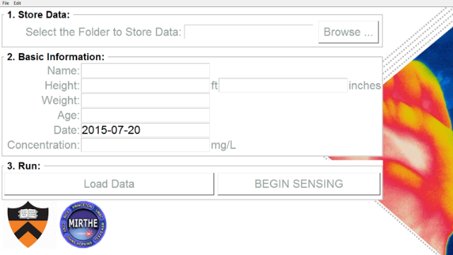 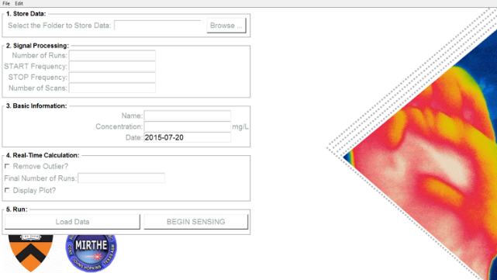 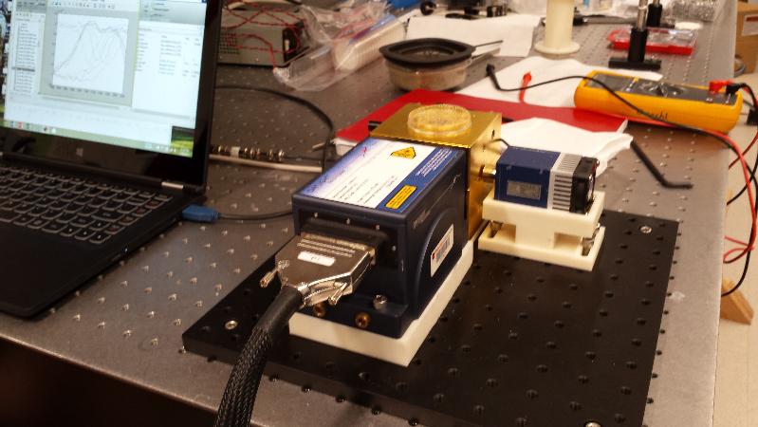

|  |
| --- |
| **(A)** Display of GUI when simplified for clinical trials. **(B)** More complex inputs allowed for solution testing in the lab. **(C)** Physical laser setup seated next to laptop.  **(A)** Display of GUI when simplified for clinical trials. **(B)** More complex inputs allowed for solution testing in the lab. |

[1] American Diabetes Association, www.diabetes.org/diabetes-basics/statistics/

[2] S. Liakat et al, “Mid-Infrared noninvasive in vivo glucose detection in healthy human subjects”, CLEO 2014, June 2014, San Jose, CA.